
PREMIER TRAINING
Home Study Courses

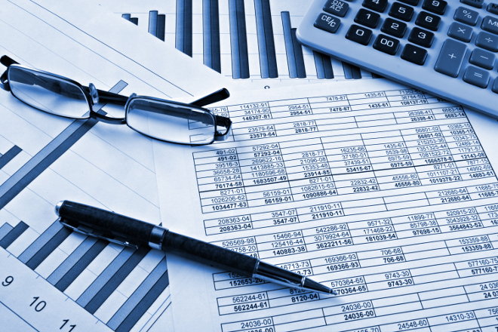

Retail Price Index

PREMIER TRAINING

Specialists in Accountancy Training

Telephone: 01469 515444
Web: www.premiertraining.co.uk

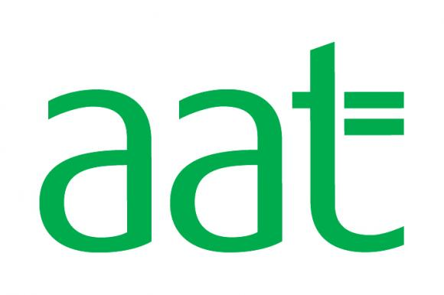

Retail Price Index

The retail price index is a measure of inflation and uses a the cost of a standard basket of items to measure by how much prices in the UK on average are rising.

To convert a historical price to its equivalent cost in the future you use the following formula:

Historical Price x Index of time of converting to
Index at time converting from

For example

In the RPI in January 1993 was 137.9, and the cost of a loaf of bread was £0.34. What is equivalent cost of this in January 2014, the RPI in January 2014 was 253.4.

So this is calculated as

0.34 x 253.4/137.9 = 62p (rounded to the nearest penny)

We can, however, use the prices to calculate the RPI.

Below are the prices for the first half of the month, what is the index figure for March, if we use January for the base year

Month | January | February | March | April
Price | £11.20 | £11.45 | £11.57 | £11.68
RPI | 100.00 | 102.23 |  | 104.29

To calculate the indexation figure we divide the new price by the base price and then multiply by the base.

So March’s indexation figure would be:

11.57/11.2 x 100 = 103.30

The principle is still the same if the base indexation factor is not 100.

What is the index figure for April, if we use February for the base year

Month | January | February | March | April
Price | £11.20 | £11.45 | £11.57 | £11.68
RPI | 157.10 | 160.61 | 162.29

So April’s indexation figure would be:

11.68/11.45 x 160.61 = 163.84

Questions

1, A Pint of beer cost £1.63 in April 2002, the RPI for April 2002 was 175.7. If the RPI for May 2009 was 212.8, what is the equivalent price for the pint of beer in 2009?

2, A bottle of wine cost £2.21 in January 1990, when the RPI was 119.5. If the equivalent price of that bottle of wine was £6.77 today, what is the current RPI?

3, What is the index figure for April, May, June, if we use March for the base year

Month | March | April | May | June
Price | £101.20 | £105.45 | £111.57 | £117.68
RPI | 157.10

Below are the RPIs for March to June, a bottle of shampoo and the price for March. If the price increased with inflation what would be the equivalent price each month?

Month | March | April | May | June
Price | £1.68
RPI | 157.10 | 157.60 | 158.65 | 160.98

Answers

1 £1.97 (1.63/175.7 x 212.8)

2 366.07 (6.77/2.21 x 119.5)

3 April: 163.70 (105.45/101.2 x 157.10) May 173.20 (111.57/101.2 x 157.1) June 182.68 (117.68 / 101.2 x 157.1)

4 April £1.69 (£1.68 /157.1 x 157.6) May £1.70 (£1.68 / 157.1 x 158.65) June £1.72 (£1.68/ 157.1 x 160.98)

